Jared Morell

ECE 570.S: GPS Software Receiver

**Homework 12**

For this assignment, it was necessary to implement a function that performs GPS signal acquisition using the time domain correlation method. The goal of acquisition is to estimate the code phase and the carrier Doppler frequency. After the signal is received at the antenna, it goes through RF amplification filtering, IF down-conversion, and IF amplification filtering. Converting the analog signal to digital, it is in the form:

$$x_{ADC}\left(t\right)=\sum_{i}{A_{i}C_{i}\left(t-t_{i0}\right)D_{i}\left(t\right)cos\left[\left(ω_{0}+ω_{di}\right)t+φ_{i}\right]+noise}$$

The signal is then down-converted to baseband before undergoing acquisition and tracking:

$$x_{B}\left(t\right)=x_{ADC}\left(t\right)e^{-jω_{0}t}=\sum_{i}{A_{i}C_{i}\left(t-t_{i0}\right)D_{i}\left(t\right)e^{jω_{di}t+jφ_{i}}+noise+high freq terms}$$

$$x_{B}\left[n\right]=\sum_{i}{A_{i}C_{i}[n-n_{i0}]D_{i}[n]e^{jω_{di}{nt}_{s}+jφ_{i}}+noise}$$

$n_{i0}$ is the estimated code phase and $ω_{di}$ is the estimated carrier Doppler frequency. When acquiring a particular satellite, j, a reference signal is first constructed:

$$x_{Rj}\left[n\right]=C_{j}[n-{\hat{n}}_{j0}]e^{-j{\hat{ω}}_{dj}{nt}_{s}}$$

The baseband signal is then cross-correlated with the reference signal. All cross-correlations between PRNs are treated as noise. When the reference code phase and the Doppler both match a PRN in the input,

$$n_{j0}={\hat{n}}_{j0 } and ω_{dj}{=\hat{ω}}_{dj} and x_{B}\left[n\right]⊗x_{Rj}\left[n\right]=A_{j}e^{jφ_{j}}n_{s}+noise$$

When the reference code phase has a match but the Doppler does not match with the input, or when the reference code does not match the input, the correlation between the baseband signal and reference signal is approximately equal to noise. This is illustrated below:

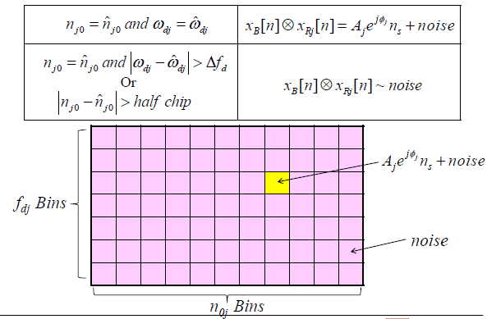

A block diagram illustrating how the coarse Doppler frequency and code phase are found is shown:

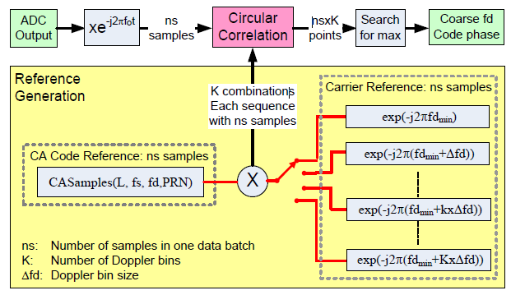

In order to determine that the program works correctly, a number of simulations were used. For the first simulation, simulated signals were generated in Matlab using a number of different PRNs, carrier-to-noise ratios, initial code phase indices, and carrier Doppler frequencies. The signal was written to a .dat file and used by the previously described program to acquire corresponding Doppler frequencies and code phases. Hardware-based simulator data was then used to test the program. This data contained two strong satellite signals, those of PRNs 7 (fd = 3 Hz, code phase index = 61) and 28 (fd = -808 Hz, code phase index = 3182). The acquired Doppler frequencies were 0 Hz and -1000 Hz, respectively. The acquired code phase indices were 61 and 3182, respectively. Real data containing weak signals was the final test for the program.